WT588D SOFTWARE USER MANUAL
Catalog
1.SOFTWARE INSTALL 2
2.SOFTWARE OPERATIONS 4
2.1.SOFTWARE INTERFACE ..4
2.1.1.OPERATION AREA 4
2.1.2. KEY INFORMATION………….…………………………………………………………………………………..........4
2.2.NEW PROJECT 5
2.3.MEMORY SIZE SETTINGS 5
2.4.LOADING VOICE 6
2.5.MODES OPTIONS 7
2.5.1.ONE LINE SERIAL INTERFACE MODE 8
2.5.2.THREE LINE SERIAL INTERFACE MODE 9
2.5.3.MP3 MODE 10
2.5.4.KEY MODE 11
2.5.5. MATRIX 3x8 MODE 12
2.5.6.PARALLEL INTERFACE MODE 13
2.6.AUDIO OUTPUT 13
2.7.BUSY SETTING 14
2.8.VOICE ADDRESSES. 15
2.9.INSERT MUTE(SILENCE) 15
2.10. DELETE AND EMPTY VOICES 13
2.11. COMPILE (SAVE BIN) 16
2.12.DOWNLOAD DATA 16
2.13.OPERATION STEPS. 19

1. SOFTWARE INSTALL
Double click the “setup_E.exe” start to setup the software to PC.
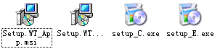

2. SOFTWARE OPERATIONS
2.1. SOFTWARE INTERFACE
Voice loading area: Load voice files here ,Voice editing area: Insert voice files form loading area, and edit. Voice files in editing area will not take up any memory space.
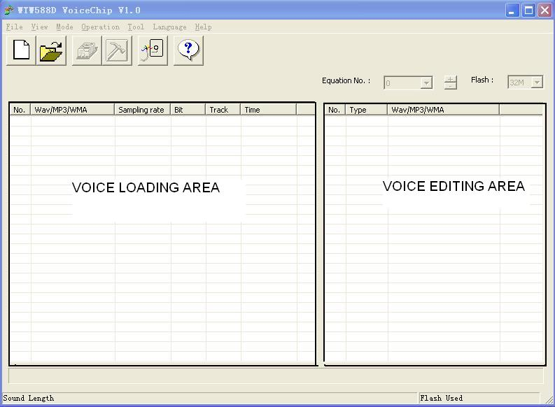

2.1.1. KEY INFORMATIONS

They are “New project” , “Open project”, “Compile (save BIN)”, “Options”, “Download data”.

2.2. NEW PROJECT
Click “File” →”New project” to create a new project.
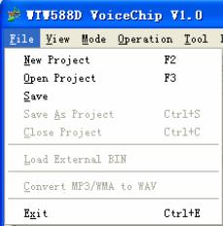
Name the project in the pop-up dialog box, and choose a folder to save it.

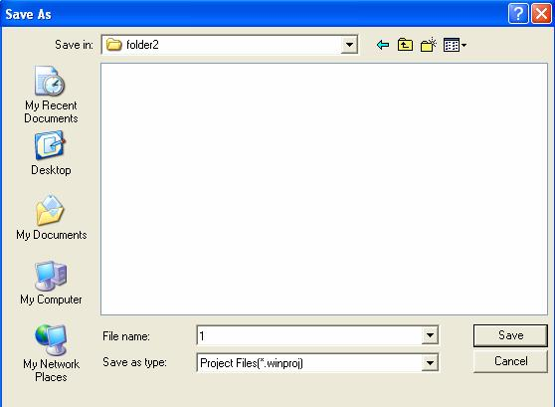
Press “save” the project will save in a new project folder, this system new folder include all the project information.

2.3. MEMORY SIZE SETTINGS
In the top right corner of software interface, SPI-Flash size can be set. There are 2M, 4M, 8M, 16M, 32M, 64M options. Choose the size according to your need. Please refer to “WT588D SUPPLY INFORMATION”.
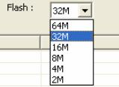

2.4. LOADING VOICE
Voice sampling rate must be 6000Hz、8000Hz、10000Hz、12000Hz、14000Hz、16000Hz、18000Hz or 20000Hz, right click the mouse button and load the voice files.
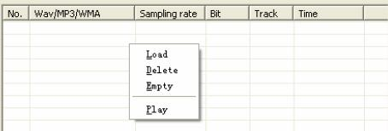
Choose the voice files, and open.

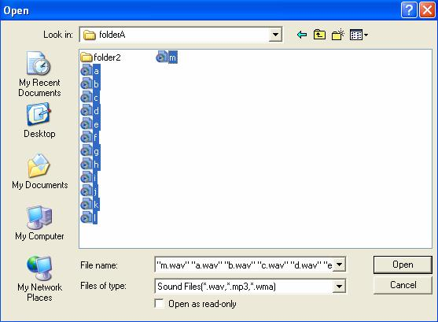
After voice loaded in, their information will show up, such as file name, sampling rate, bit, track, duration.

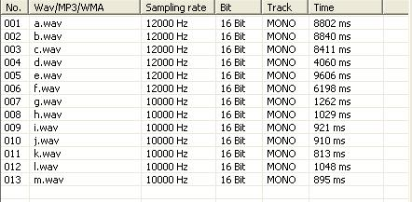

2.5. MODES OPTIONS.
Click “Operation” →” Options” enter into the interface.
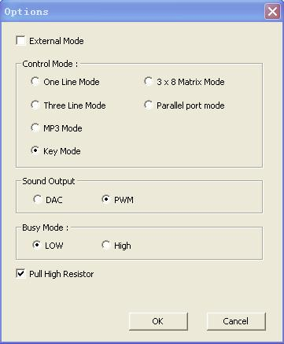
There are 6 control modes, default is “Key mode”.

2.5.1. ONE LINE SERIAL MODE
Click “Operation” →”Options”, choose “one line mode” and press “OK”.
Click “Operation” →”Key setup”, you can see each I/O corresponding KEY, KEY 1 to KEY 10 default. KEY 4 (corresponding I/O P03) is locked up, P03 is DATA pin in the mode, can not be used as a key. Other I/Os can be used as keys. Trigger mode including “No function”, “Edge retrigger”, ”Edge no retrigger”, ”Level hold loop”, “Level loop” ,”On/off” ,”Next unloop”, “Prev unloop” ,”Next loop” ,” Prev loop” ,”Level unloop”, “Pause” ,”Vol+”, “Vol-“,”Stop”.
After choose trigger mode, when the corresponding key(I/O) set to low level, voice can be trigger to play in the set trigger mode.
The available keys(I/Os) were defaulted as “Edge retrigger”.

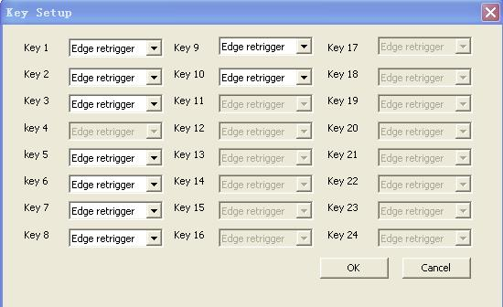
Click “Operation” →”Equation setup”, to set each key’s (I/O’s) trigger address.
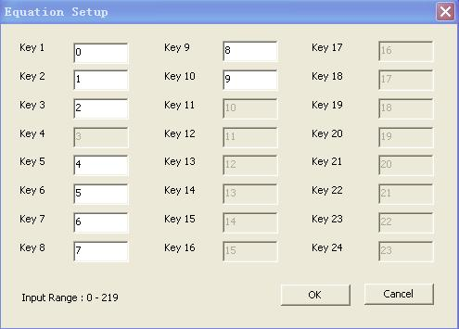
KEY 1 to KEY 10 default trigger address 0～9, the addresses can be changed input number between 0～219. The following trigger modes can direct trigger voice addresses . “Edge retrigger”, “ Edge no retrigger” ,”Level hold loop”, “Level loop”,” On/off” ,”Level unloop”. Only the corresponding key(I/O) set to these trigger modes, addresses can be triggered directly.
Addresses information please refer to 2.8 VOICE ADDRESSES

2.5.2. THREE LINE SERIAL MODE
Click “Operation” →”Options”, choose “three line mode” and press “OK”. In this mode, all the I/Os can not be used as keys. As you can see all the keys were locked up.
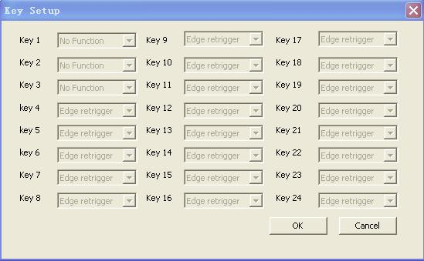
Open “Operation” →”Equation” ,Key 2(P01), Key 3(P02), Key4(P03) were locked up. Other keys also invalid here.

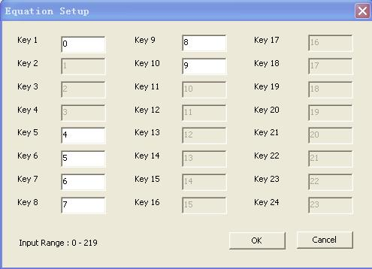

2.5.3. MP3 MODE
Click “Operation” →”Options”, choose “MP3 mode” and press “OK”.
In this mode, Key 1 to Key 6 default as “STOP”, “ON/OFF”,”NEXT”,”PREV”,”VOL+”,”VOL-“ individually. Other I/Os are invalid.
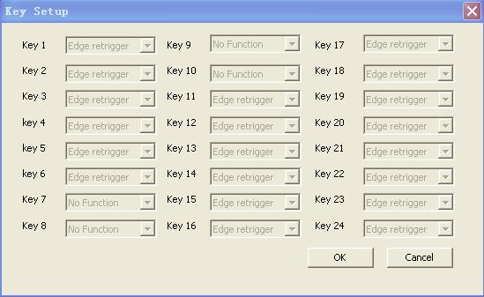
Open “Operation” →”Equation”, Key 1 to key 6 addresses were locked up. Others invalid.

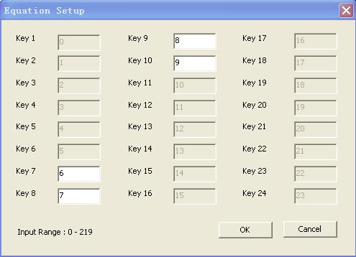
2.5.4. KEY MODE
Click “Operation” →”Options”, choose “MP3 mode” and press “OK”.
In this mode, Key 1(P00), Key2(P01), Key3(P02), Key4(P03), Key5(P04), Key6(P05), Key7(P06), Key8(P07), Key9(P10), Key 10(P11) all are valid. Open “Operation” →“Key set”, Keys (I/Os) trigger mode can be changed by drop-down menu. The default trigger mode is Edge retrigger.

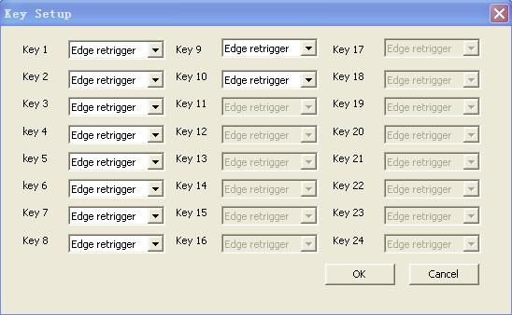
Trigger addresses can be changed by input addresses.

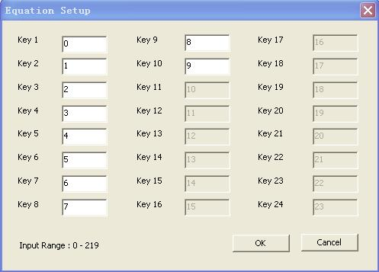
KEY 1 to KEY 10 default trigger address 0～9, the addresses can be changed input number between 0～219. The following trigger modes can direct trigger voice addresses . “Edge retrigger”, “ Edge no retrigger” ,”Level hold loop”, “Level loop”,” On/off” ,”Level unloop”. Only the corresponding key(I/O) set to these trigger modes, addresses can be triggered directly.
Addresses information please refer to 2.8 VOICE ADDRESSES

2.5.5. MATRIX 3x8 MODE
Click “Operation” →”Options”, choose “Matrix 3X8 mode” and press “OK”.
In this mode, voice address triggered by Matrix( consist of I/Os), all the keys were locked up, and Edge retrigger. Open “Operation” →”Key setup” , all keys locked.

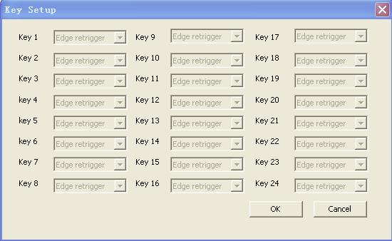
Open “Operation” →”Equation setup”, 24 voice addresses can be set from 0～219

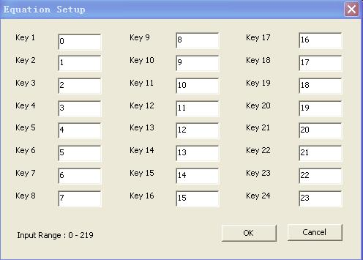

2.5.6. PARALLEL MODE
Click “Operation” →”Options”, choose “Matrix 3X8 mode” and press “OK”.
In this mode, Key1 (P00) defined as SBT pin, P01, P02, P03, P04, P05, P06, P07, P10 are addresses.
Open “Operation” →”Key setup”, only key 1‘s trigger mode can be changed. We suggest set to “Edge retrigger” or “ Edge no retrigger” or ”Level hold loop” or “Level loop” or ” On/off” or ”Level unloop”. Because these modes can direct trigger voice addresses.
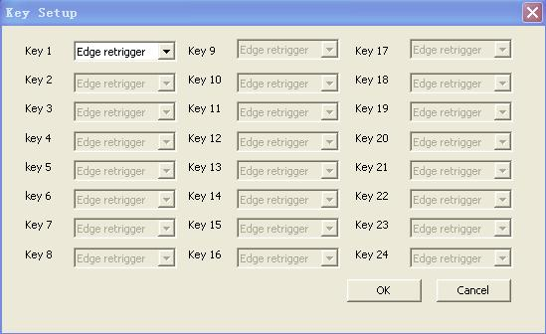
Open “Operation” →”Key setup”, key1 setup change is invalid.

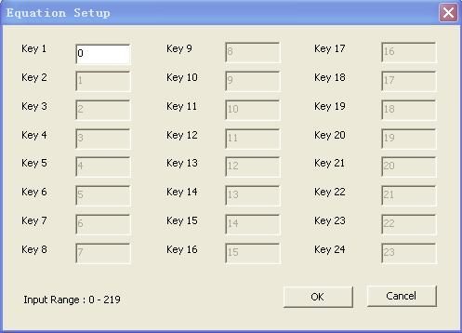

2.6. AUDIO OUTPUT
Open “Operation” →”Options” and choose audio output mode.
DAC output: external amplifier is needed
PWM output: direct drives speaker

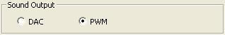

2.7. BUSY SETTING
Open “Operation” →”Options”, to set the BUSY port(I/O P17) high level or low level when playing voice.
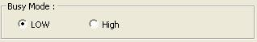

2.8. VOICE ADDRESSES
Choose the Equation NO. by “+” or “-“ ,and load (double click left button or click right button )the voice files from “VOICE LOADING AREA”, voice files can be reused.
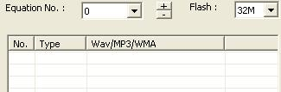
There are 0～219 options in “ Equation NO.”, up addresses by “+” (or “W”) , down addresses by “-“(or “S”) .
For example, set Key 1 trigger mode as “Edge retrigger”, Equation No. as 0, Key 1(P00) can trigger voices to play in order in address 0.
There are 220 voice addresses total. 85 groups of voice can be load to each address max. Mute also can be inserted.
The same voice use in other addresses, will not take additional memory space. (just take one voice space). At the same time, mute will not take space also. The total size depends on the size of voices in “VOICE LOADING AREA”.

2.9. INSERT MUTE (SILENCE)
Right click mouse button in “VOICE EDITING AREA”, choose “Insert” → ” User defined silence ”, also 10ms、20ms、50ms、100ms、200ms、300ms silence can be chosen directly.

For example insert 10ms mute between voice 1 and voice 2 , after voice 1 played, there are 10ms mute, and then play voice 2.
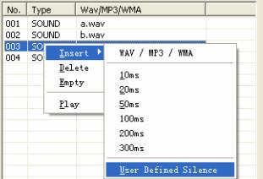
Also in “User defined silence” insert silence. Such as insert 100ms.

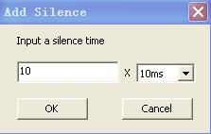
After input multiple, and “OK” 100ms silence already inserted.
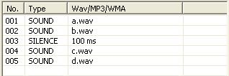

2.10. DELETE AND EMPTY VOICES
In the “VOICE LOADING AREA” we can choose the voice and delete one by one. Also choose “EMPTY”, to delete all the voices by one time . also will empty all the voice in” VOICE EDITING AREA”.
In the” VOICE EDITING AREA”, we can choose the voice and delete one by one. Choose “EMPTY”, to delete all the voices in current address by one time. Other addresses voices will not be deleted.

2.11. COMPILE (SAVE BIN)
After finish the project, we have to compile it as BIN file, and download to SPI-Flash on WT588D module.
Open “Operation” →”Compile (save bin)” or press”F4”, to compile Bin file.
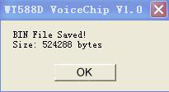
If the Bin file size big than the SPI-Flash memory, there will be a pop up dialog box to inform you change bigger memory.
The percentage (the Bin file take the memory size) will show in the lower right corner .

2.12. DOWNLOAD DATA
Put the module on the programmer properly and connect to the PC by USB ,Open “Tool” →”download data”, or press F5 ,download data to Flash memory.
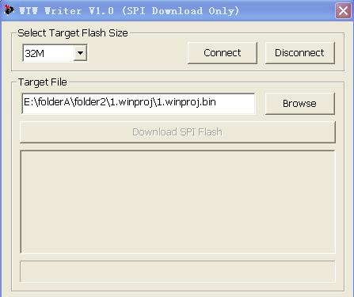
Select the Flash size you are going to program. And then click “Connect” .

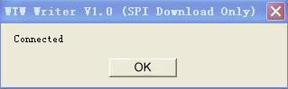
Click “OK” to keep going.

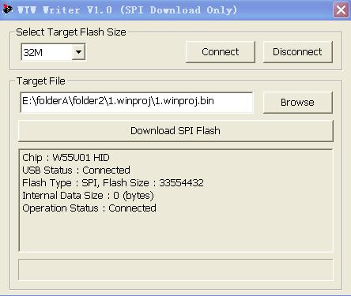

Click “Download SPI Flash”, and will into erasing status.

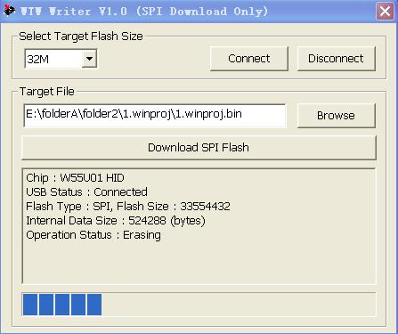

After finish erasing, into Downloading status.

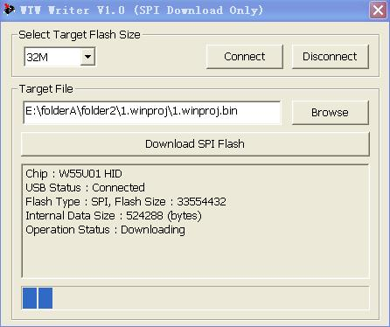

Download Ok, all the data already in SPI –Flash memory.

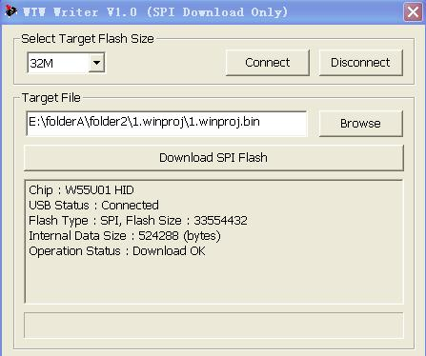

2.13. OPERATION STEPS
New project

Choose memory size

Loading voice

Control mode settings

Choose audio output

Set BUSY mode

Key setup &Equation setup

Load voice to addresses

Compile

Download

Note: If you already have Bin file, you can open it by PC software and download data directly, Unnecessary to editing the voice again.

